**LAB#03**

**HISTOGRAM EQUALLIZATIO**N

Histogram equalization is a technique of improving the contrast and visual quality of a digital image. Histogram equalization redistributes the values of pixel intensities throughout the image more uniformly. Overall, histogram equalization is a technique of balancing the pixel intensities of an image. A histogram is a graph or figure that shows the frequency distribution of pixel intensities in an image.

Histogram equalization of an image involves several different processes such as computing cumulative distribution function (CDF), transformation function, and then applying these functions to equalize the image.

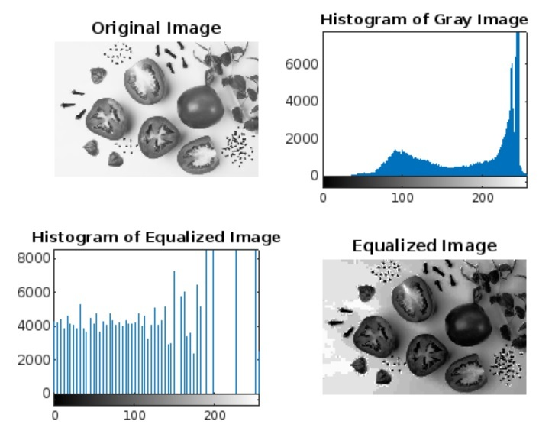

IMPORTANT POINTS

* Histogram equalization is a global image enhancement process, as it utilizes the histogram of the entire image to perform enhancement.
* Histogram equalization is not a suitable technique to enhance the visual quality of all kinds of images, as it can create unrealistic enhancements.
* Histogram equalization is considered an effective method to enhance low contrast images.

**TASK:** Write a code for Histogram equalization and show the results.